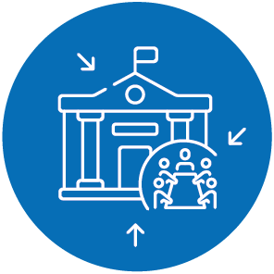

SMARTER EUROPE
PROJECT ACRONYM
Project full title or key message

Optional: Grab your reader’s attention with a great message or use this space to emphasise a key point. If on screens, you can use this also for e.g. venue instructions.

