PROJECT REPORT
Offline template

A.1 Project progress report identification

Project ID number |  | Pre-filled from AF
Project acronym |  | Pre-filled from AF
Name of the lead partner organisation (original language or English language) |  | Pre-filled from AF
Project report number |  | Automatically generated
Reporting period start date |  | DD.MM.YYYY
Reporting period end date |  | DD.MM.YYYY

A.2 Highlights of main achievements

Please describe project progress up to now including specific objectives reached and main outputs delivered by highlighting also the added-value of the cooperation. The summary should highlight main achievements, and be interesting and understandable for non-specialists.
[2500 characters]
We are looking for a concise description of the project’s progress in terms of the activities, deliverables and outputs delivered in this reporting period, and the results overall.
The description should be coherent with the activities and expenses listed in other parts of this Project Report.
Please highlight any main achievements, and collaboration with other programmes. We would like to capture positive impacts of your work, tangible or intangible, anticipated or unexpected.

A.3 Overview of the outputs and results achievement

This is an overview table displaying information from the application form, project progress reports and values that are automatically calculated.

Project outputs | Project output number | From AF
 | Output title | From AF
 | Output target value | From AF
 | Previously reported | Sum of previously reported values
 | Currently reported | In this progress report
 | Total so far (sum of values from previous and from this reporting period) | Automatically calculated
Programme output indicators | Programme output indicator | From AF
 | Programme output indicator target value | Automatically calculated from data in AF
 | Previously reported | Sum of previously reported values
 | Currently reported | Sum of values achieved in this reporting period from outputs contributing to this programme output indicator
 | Total so far (sum of values from previous and from this reporting period) | Automatically calculated
Programme result indicators | Programme result indicator number | From AF
 | Programme result indicator | From AF
 | Result indicator target value | From AF
 | Previously reported | Sum of previously reported values
 | Achieved in this reporting period | From this progress report
 | Total so far (sum of values from previous and from this reporting period) | Automatically calculated

A.4 Project problems and deviations

If applicable, please describe and justify any problems and deviations, including delays from the work plan presented in the application form, and the solutions found.
Please assess for the points below the potential risks for a successful project implementation (low/medium/high) and how you will mitigate these risks. Objectives, outputs, results (project feasibility, critical path, stakeholder engagement, viability of outputs, dissemination);
- Partnership development, and cooperation dynamics;
- Budget (spending level, eligibility issues, State Aid);
- Other.
Do you foresee any difficulties with achieving the outputs and results, or for the relevance of the results?

Enter text here [2000 characters]
We would like to get an insight into any problems and deviations affecting the project work during this period, and how you handled this as a partnership. This gives us an idea how the project is faring, and if there is anything the programme bodies can do to help the situation. In addition, we would like to capture how the project’s risk profile is developing.

Only if relevant, project changes should be reported here. Please refer to the Programme Manual for managing project changes.

If applicable, please describe any deviations in the spending profile compared to the amounts indicated in the application form.
Enter text here [1000 characters]
Only if relevant, changes to the project budget should be reported here. Please refer to the Programme Manual for managing project changes.

A.5 Target groups

In the table below you will see a list of the target groups you indicated in the application form. Please explain for each target group in what way and to what extent they were involved in your project in this reporting period.

Target group | Description of the target group involvement
Target group 1  (automatically inserted from AF) | Enter text 1000 characters]  We would like to capture how the target group was involved in the project activities during this period, and in what context. Indicate if underrepresented groups were reached.  If relevant, you may indicate the number of people you reached in this target group.  Please include the current and cumulated value including previous reports. Make sure you have background documentation and that no double counting occurs (ref. Programme Manual Annex 6.1).

A.6 Work plan progress

A.6.1 Work package 1

This work package is completed.

A.6.1.1 What is the progress towards the objectives in this work package as defined in the application form? Status should be cumulative.

Objectives | Status | Explanations
Specific objective 1  (pre-filled from AF – WP1) | Drop-down list: Fully achieved, partly achieved, not achieved | Please describe how the work carried out in this period contributed towards this project specific objective.  1000 characters
Communication objective 1.1  (pre-filled from AF – WP1) | Drop-down list: Fully achieved, partly achieved, not achieved | Please describe how the work carried out in this period contributed towards this communication objective  1000 characters

A.6.1.2 Please describe the progress in this reporting period and explain how partners were involved (who did what).
Enter text here. We are trying to get an insight into the partnership dynamics and the division of roles. If relevant, please expand on how the partnership addressed issues and deviations in this WP
1000 characters

A.6.1.3 Please indicate progress made in each activity, deliverable and output.
It is possible to upload 1 attachment per activity. If several files, please upload a zipped folder.

Nr. | Activity title | Start period | End period | Status | Progress
A 1.1 | Pre-filled from AF | Pre-filled from AF | Pre-filled from AF | Drop-down list: not achieved, partly achieved, fully achieved | Describe progress achieved in this reporting period and deviations  1000 characters

Deliverable
Deliverable number | Pre-filled from AF, e.g. D 1.1
Deliverable title | Pre-filled from AF
Delivery period | Pre-filled from AF
Achieved in this reporting period | If relevant, enter the number.
Cumulative value (values from previous and from this reporting period) | Automatically calculated
Progress in this period | Describe progress achieved or deviations. Specify if the deliverable is in a draft or finalised version.  1000 characters
Evidence attached to this report  (If applicable) | One attachment per deliverable. If several files. Please submit a zipped folder.

Output
Output number | Pre-filled from AF, e.g. OI 1.1
Output title | Pre-filled from AF
Programme output indicator | Pre-filled from AF
Measurement unit | Pre-filled from AF
Delivery period | Pre-filled from AF
Output target value | Pre-filled from AF
Achieved in this reporting period | Enter the number
Cumulative value (values from previous and from this reporting period) | Automatically calculated
Progress in this period | Describe the progress achieved and deviations.  1000 characters
Evidence attached to this report  (If applicable) | One attachment per deliverable. If several files. Please submit a zipped folder.  Please refer to Programme Manual Annex 6.1 about how to document the achievement of your outputs/output indicators.  In case this output is achieved, don’t forget to upload the output documentation (link and template will follow).

A.7 Project results

Please indicate the progress made in achieving the project results.

Result number | Pre-filled from AF, e.g. RI 1.1
Programme result indicator | Pre-filled from AF
Baseline | Pre-filled from AF
Measurement unit | Pre-filled from AF
Delivery period | Pre-filled from AF
Result indicator target value | Pre-filled from AF
Achieved in this reporting period | Enter the number
Cumulative value (values from previous and from this reporting period) | Automatically calculated, also displayed in %
Progress in this period | Describe progress achieved  2000 characters
Evidence attached to this report  (if applicable) | One attachment per deliverable. If several files. Please submit a zipped folder.  Please refer to Programme Manual Annex 6.2 about how to document the achievement of your results/result indicators.  In case this result is achieved, don’t forget to upload the result documentation (link and template will follow).

A.8 Horizontal principles

Please describe specific measures used to apply horizontal principles during the project implementation.
Please report on concrete steps and activities your project took during this reporting period to address the horizontal principle. Also describe the impact of the measure(s) taken and give concrete examples.

Horizontal principles | Type of contribution | Description of the contribution
Sustainable development | drop-down: neutral, positive effects, negative effects | 1000 characters
Equal opportunities and non-discrimination | drop-down: neutral, positive effects, negative effects | Enter text
Gender Equality | drop-down: neutral, positive effects, negative effects | Enter text

A.9 List of partner certificates

In this section you can find all partner certificates of this project. A partner certificate can only be included once. Once ticked, the certificate is unavailable in other reports.

If deemed necessary, the Lead Partner can decide not to include a certificate in the project claim. To do so, the certificate must be un-ticked and a justification added to the project report section A.4 Problems and deviations. However, it is recommended that all certificates belonging to the same period are included in the corresponding project report.

All certificates are automatically ticked. Data automatically filled in.
 | Partner | Partner Report | Date of certificate | Included in project report | Amount certificate  (in Euro)
 | PP2 | R.1 | 07/06/2023 19:41 | PR.1 | 10.000,00
 | LP1 | R.1 | 07/06/2023 19:41 | PR.1 | 15.000,00

A.10 Project report annexes

Overview of the files attached in the previous sections. It is also possible to add further documents here.

A.11 Financial overview
The values displayed below consist of certified amounts & fast track lump sums (if applicable) in Euro only.

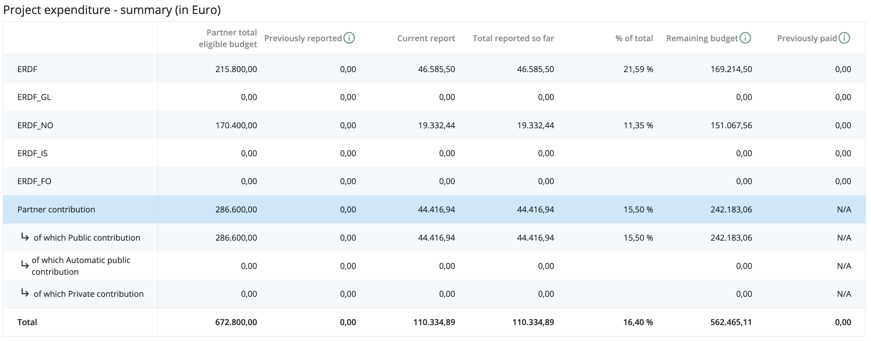
Previously reported: represents amounts from certificates already included in previously submitted reports by the date of creation of the current report and lump-sums if applicable.
Current report: certified amounts included in this report.
Total reported so far: certified amounts included in all project claims submitted to date of creation of this report.
Remaining budget: difference between “Total eligible budget” and “Total reported so far”.
Previously paid: amounts paid by the date of creation of the current report.

